**Лабораторно упражнение номер 2**

Име: Виктор Методиев  
фак. Номер: 361223016

Курс: 2

Група: 21

Факултет: ФИТ

**TASK 1: Additional tasks Week 02. Database – Players**

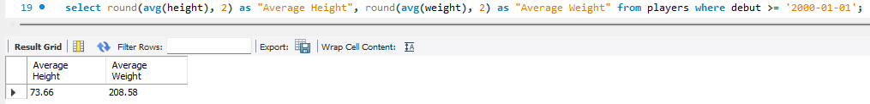

**TASK 2: database – employees.**

